Documentation

* This travel agency website consists of eight major pages.
* The navigation bar can direct the user to this pages.
* The pages are as follows: Flights, Cruises, Hotels, Hot Deals, Explore, About, Contact & Members
* **Main Landing Page**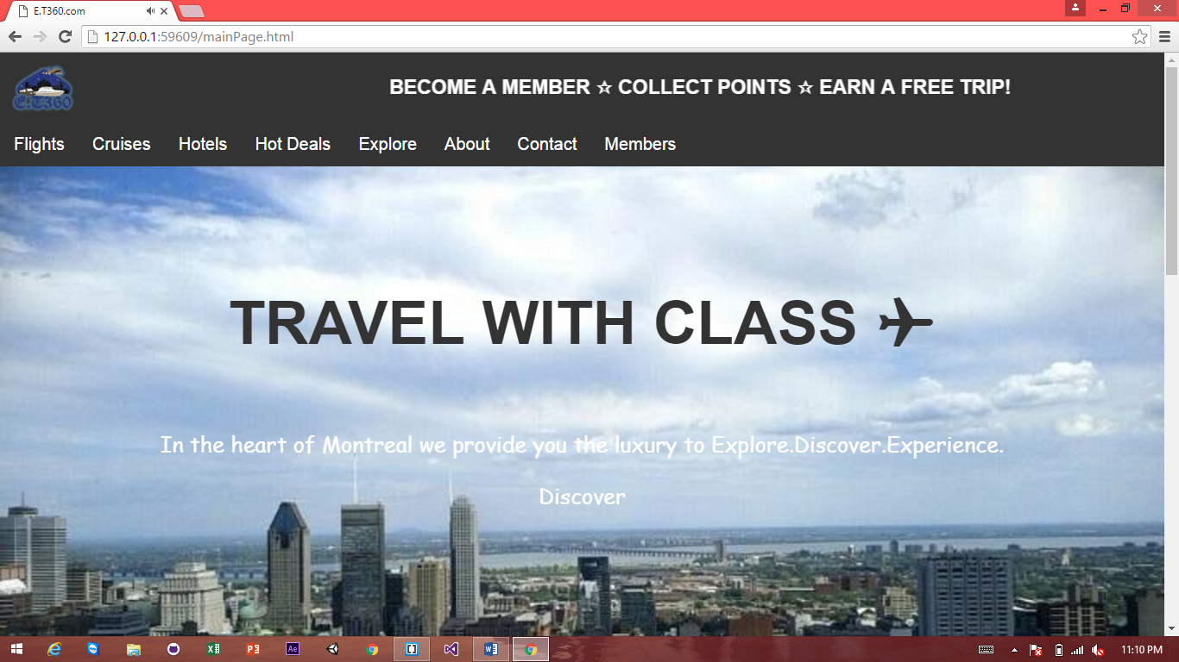

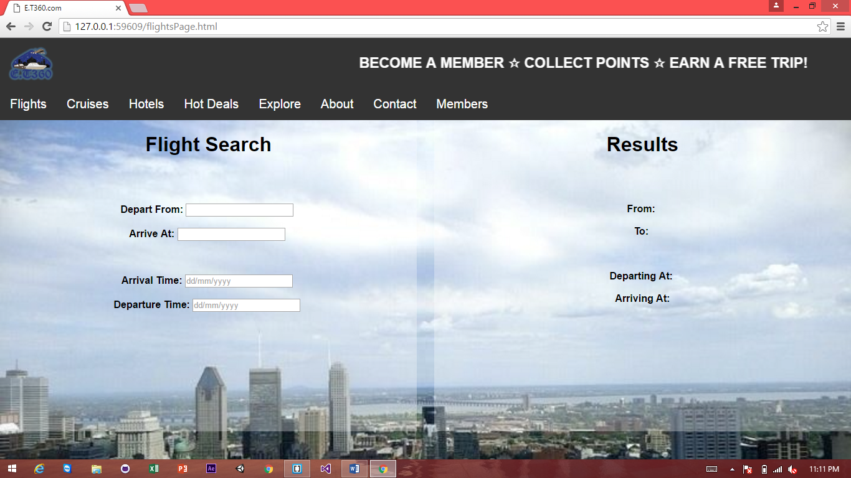**Flights tab**

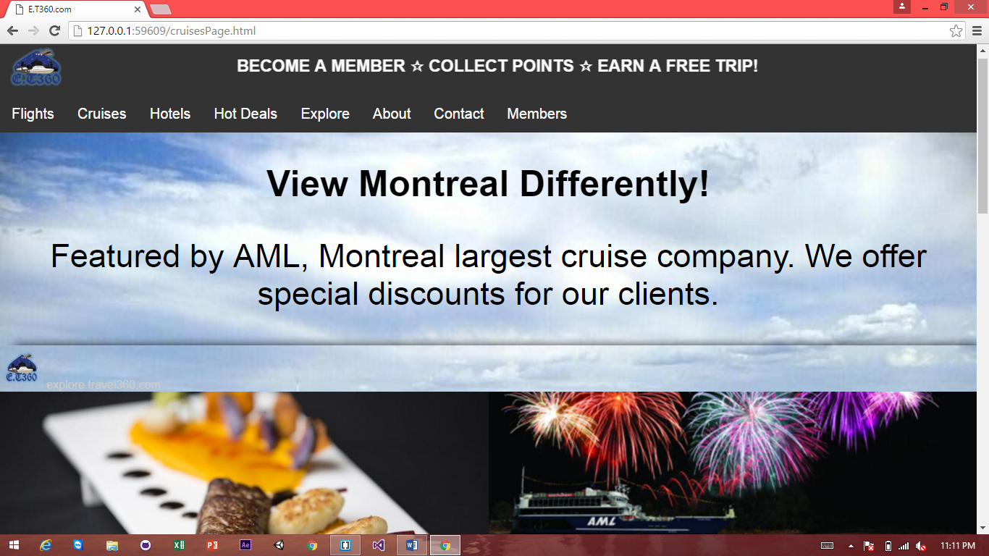**Cruises Tab**

**Explore tab**

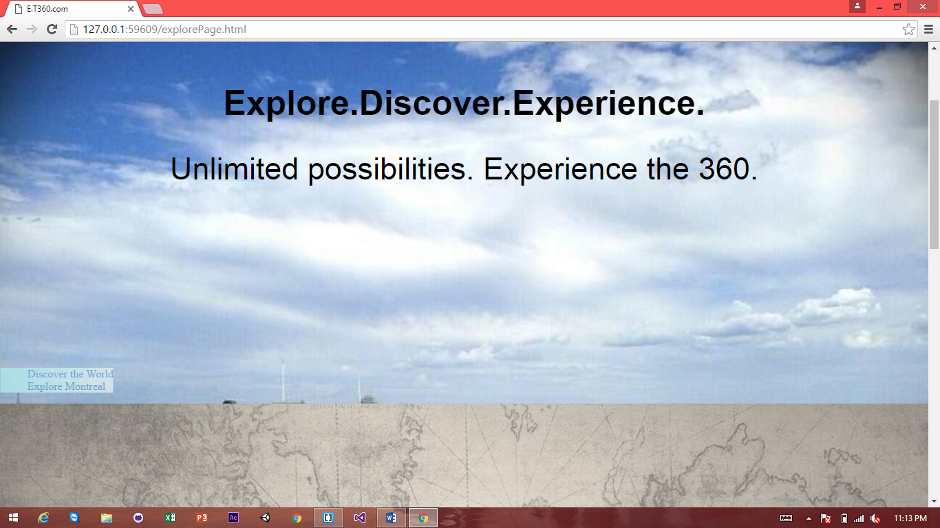

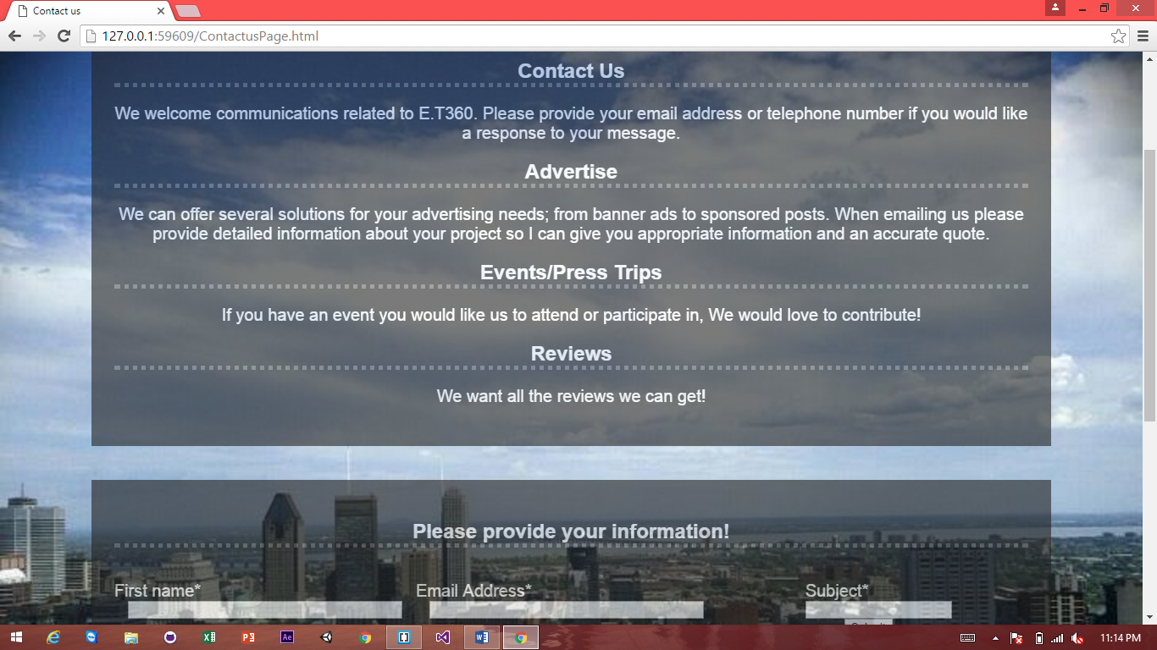**Contact Us Tab**

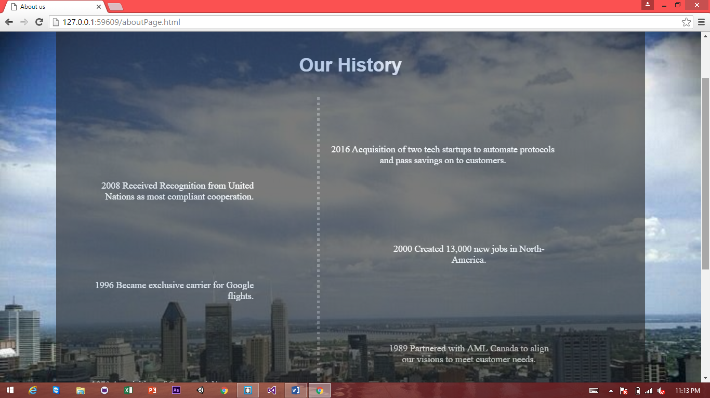**Our History**

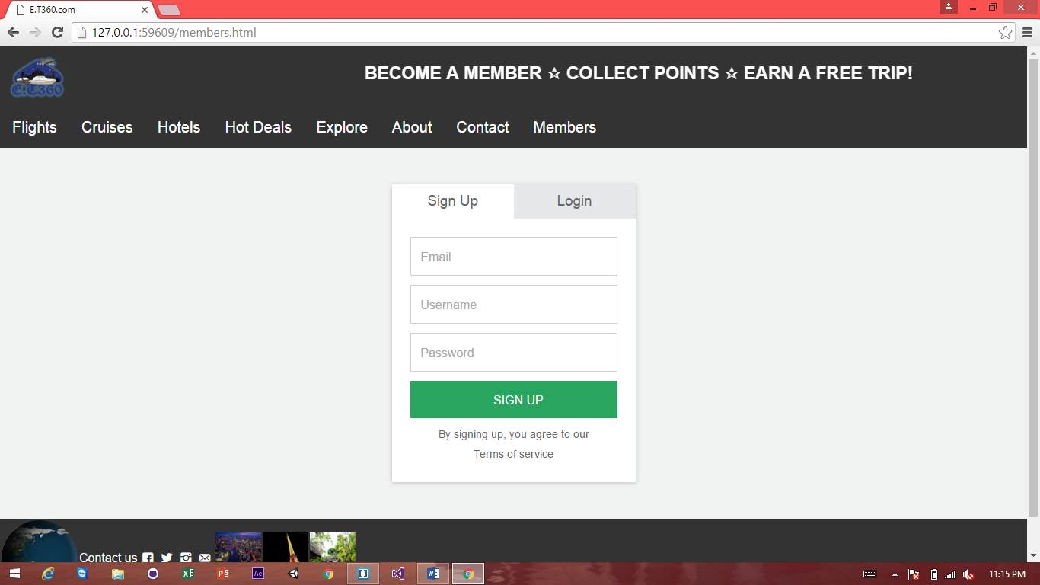**Member Tab**

**Summary of each Tab**

* Main Landing Page

Welcomes User with a beautiful introductory video. Incentivize them to become member and start earning points towards a free trip !

* Flights tab

Allows User to find flights they are looking for at affordable prices !

* Cruises Tab

Has a variety of luxurious packages to choose from. An amazing experience for all.

* Explore tab

Familiarize yourself with Montreal or even the globe at large

* Contact Us Tab

Have a question , Get in touch. We are here to help !

* Our History

Who we are, what we do and what we believe in !

* Member Tab

Aren’t a member yet, sign up and earn points today !

**Functionality of each Tab**

* Main Landing Page

HTML Embedded Video, Divs, Tables, CSS styling, Photo Links, External links

* Flights tab

Divs, Google flights Api, CSS styling, External Links.

* Cruises Tab

Tables, Divs, JavaScript, JQuery, Cookies, External Links.

* Explore tab

Internal Links, External Links, Mapping, CSS filters & Styling

* Contact Us Tab

CSS alpha transparency, CSS styling, Raw HTML, User Data Collection

* Our History

CSS styling, JS animations, Use of timers, Web Responsiveness, External Links

* Member Tab

JavaScript, CSS Styling, External Links, JS Animations